|  |  |  |
| --- | --- | --- |
| Exercise 1–25  Objectives of Managerial Accounting Activity  (**LO 1-3**, **1-4**) | For each of the following activities, explain which of the objectives of managerial accounting activity is involved. In some cases, several objectives may be involved.   1. Measuring the cost of the inventory of tablet computers on hand in a retail electronics store. 2. Estimating the annual operating cost of a newly proposed branch bank. 3. Measuring the following costs incurred during one month in a hotel owned by a national hospitality-industry firm.    1. Wages of table-service personnel.    2. Property taxes. 4. Comparing a hotel's room rate structure, occupancy rate, and restaurant patronage with industry averages. 5. Developing a bonus reward system for the managers of the various offices run by a large travel agency. 6. Comparing the actual and planned cost of a consulting engagement completed by an engineering firm. 7. Determining the cost of manufacturing a tennis racket.   Objectives of Managerial Accounting   1. Providing information for decision making and planning. 2. Assisting managers in directing and controlling operational activities. 3. Motivating managers and other employees toward the organization's goals. 4. Measuring the performance of activities, subunits, managers, and other employees within the organization. 5. Assessing the organization's competitive position, and working with other managers to ensure the organization's long-run competitiveness in its industry. | |
| ■ Exercise 1–26  Managerial Accounting and Decision Making  (**LO 1-2**, **1-3**) | | http://textflow.mheducation.com/figures/0077632478/blue_line.jpg  Give an example of managerial accounting information that could help a manager make each of the following decisions.   1. The production manager in an automobile plant is deciding whether to have routine maintenance performed on a machine weekly or biweekly. 2. The manager of a discount department store is deciding how many security personnel to employ for the purpose of reducing shoplifting. 3. The county board of representatives is deciding whether to build an addition onto the county library. 4. The president of a rental car agency is deciding whether to add luxury cars to the rental car fleet. |

|  |  |
| --- | --- |
| Problem 2–52  Cost Classifications; Government Agency  (**LO 2-8**, **2-9**, **2-10**) | http://textflow.mheducation.com/figures/0077632478/blue_line.jpg  The Department of Natural Resources is responsible for maintaining the state's parks and forest lands, stocking the lakes and rivers with fish, and generally overseeing the protection of the environment. Several costs incurred by the agency are listed below. For each cost, indicate which of the following classifications best describe the cost. More than one classification may apply to the same cost item.  Cost Classifications   1. Variable 2. Fixed 3. Controllable by the department director 4. Uncontrollable by the department director 5. Differential cost 6. Marginal cost 7. Opportunity cost 8. Sunk cost 9. Out-of-pocket cost 10. Direct cost of the agency 11. Indirect cost of the agency 12. Direct cost of providing a particular service 13. Indirect cost of providing a particular service   Cost Items   1. Cost of the fish purchased from private hatcheries, which are used to stock the state's public waters. 2. The difference between (*a*) the cost of purchasing fish from private hatcheries and (*b*) the cost of running a state hatchery. 3. Cost of producing literature that describes the department's role in environmental protection. This literature is mailed free, upon request, to schools, county governments, libraries, and private citizens. 4. Cost of sending the department's hydroengineers to inspect one additional dam for stability and safety. 5. Cost of operating the state's computer services department, a portion of which is allocated to the Department of Natural Resources. 6. Cost of administrative supplies used in the agency's head office. 7. Cost of providing an 800 number for the state's residents to report environmental problems. 8. The cost of replacing batteries in sophisticated monitoring equipment used to evaluate the effects of acid rain on the state's lakes. 9. Cost of a ranger's salary, when the ranger is giving a talk about environmental protection to elementary school children. 10. Cost of direct-mailing to 1 million state residents a brochure explaining the benefits of voluntarily recycling cans and bottles. 11. The cost of producing a TV show to be aired on public television. The purpose of the show is to educate people on how to spot and properly dispose of hazardous waste. 12. Cost of the automobiles used by the department's rangers. These cars were purchased by the state, and they would otherwise have been used by the state police. 13. Cost of live-trapping and moving beaver that were creating a nuisance in recreational lakes. 14. The department director's salary. 15. Cost of containing naturally caused forest fires, which are threatening private property. |

|  |  |
| --- | --- |
| Exercise 2–28  Schedules of Cost of Goods Manufactured and Sold; Income Statement  Exercise 2-28 Build a Spreadsheet excel worksheet  (**LO 2-1**, **2-3**, **2-6**) | http://textflow.mheducation.com/figures/0077632478/blue_line.jpg  Alhambra Aluminum Company, a manufacturer of recyclable soda cans, had the following inventory balances at the beginning and end of 20x1.  http://textflow.mheducation.com/figures/0077632478/pg_63q.jpg  During 20x1, the company purchased $240,000 of raw material and spent $420,000 for direct labor. Manufacturing overhead costs were as follows:  http://textflow.mheducation.com/figures/0077632478/pg_63a.jpg  Sales revenue was $1,210,000 for the year. Selling and administrative expenses for the year amounted to $105,000. The firm's tax rate is 35 percent.  Required:   1. Calculate cost of goods manufactured. 2. Calculate cost of goods sold. 3. Calculate income |

|  |  |  |
| --- | --- | --- |
| Exercise 2–31  Economic Characteristics of Costs  (**LO 2-1**, **2-10**)  **This icon indicates international setting.**  International Setting | http://textflow.mheducation.com/figures/0077632478/blue_line.jpg  Thomas Cleverly purchased a vacant lot outside of London for £17,200, because he heard that a shopping mall was going to be built on the other side of the road. He figured that he could make a bundle by putting in a fast-food outlet on the site. As it turned out, the rumor was false. A sanitary landfill was located on the other side of the road, and the land was worthless. (£ denotes the British monetary unit, pounds sterling. Although the Euro generally is used in European markets, day-to-day business in the United Kingdom is still conducted in pounds sterling.)  Required:What type of cost is the £17,200 that Thomas paid for the vacant lot? | |
| ■ Exercise 2–32  Fixed, Variable, Marginal, and Average Costs; Hotel  (**LO 2-1**, **2-8**, **2-10**) | | http://textflow.mheducation.com/figures/0077632478/blue_line.jpg  A hotel pays the phone company $200 per month plus $.15 for each call made. During January 7,000 calls were made. In February 8,000 calls were made.  Required:   1. Calculate the hotel's phone bills for January and February. 2. Calculate the cost per phone call in January and in February. 3. Separate the January phone bill into its fixed and variable components. 4. What is the marginal cost of one additional phone call in January? 5. What was the average cost of a phone call in January? |

|  |  |  |
| --- | --- | --- |
| ■ Exercise 2–34  Economic Characteristics of Costs  (**LO 2-1**, **2-10**) | http://textflow.mheducation.com/figures/0077632478/blue_line.jpg  Suppose you paid $75 for a ticket to see your university's football team compete in a bowl game. Someone offered to buy your ticket for $100, but you decided to go to the game.  Required:   1. What did it really cost you to see the game? 2. What type of cost is this? | |
|  | |  |

|  |  |
| --- | --- |
| ■ Exercise 2–35  Differential Cost  (**LO 2-1**, **2-10**) | http://textflow.mheducation.com/figures/0077632478/blue_line.jpg  Global Communications, Inc. manufactures communications satellites used in TV signal transmission. The firm currently purchases one component for its satellites from a European firm. A Global Communications engineering team has found a way to use the company's own component, part number A200, instead of the European component. However, the Global Communications component must be modified at a cost of $650 per part. The European component costs $9,100 per part. Global Communications' part number A200 costs $4,900 before it is modified. Global Communications currently uses 15 of the European components per year.  Required:Calculate the annual differential cost between Global Communications' two production alternatives. |

|  |  |
| --- | --- |
| Problem 2–51  Interpretation of Accounting Reports  (**LO 2-1**, **2-3**)  Business Communication | http://textflow.mheducation.com/figures/0077632478/blue_line.jpg  Refer to Exhibit 2-3, and answer the following questions.  Required:   1. List the major differences between the income statements shown for Caterpillar, Walmart, and Southwest Airlines. 2. Explain how cost-accounting data were used to prepare these income statements. 3. On the income statement for Southwest Airlines, where would the airline's ticket agents' salaries be shown? Where would the costs of the computer equipment used to keep track of reservations be included on the statement? 4. On the income statement for Walmart, where would the cost of newspaper advertising be shown? How about the cost of merchandise? 5. Refer to the income statement for Caterpillar. Where would the salary of the brand manager who plans advertising for Caterpillar equipment be shown? How about the salary of a production employee? Where would the cost of the raw materials used in the company's products be included on the statement? |

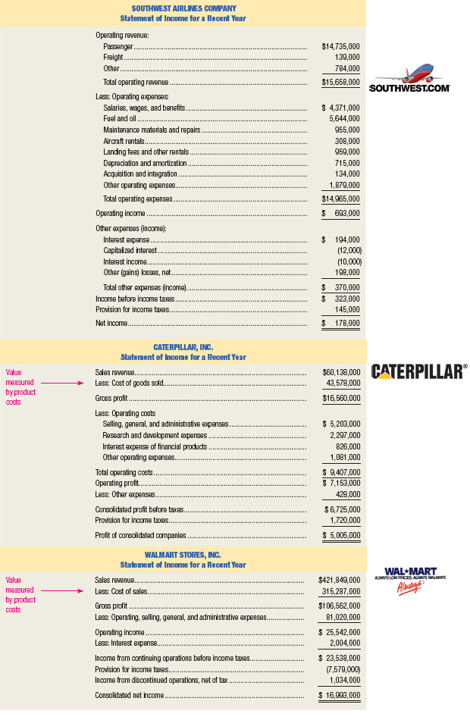

|  |  |
| --- | --- |
| Problem 6–35  Cost Behavior Patterns in a Variety of Settings; International Issues.  (LO 6-1, 6-2)  International Setting | For each of the following cost items (1 through 11), choose the graph (a through l) that best represents it.   1. The cost of utilities at a university. For low student enrollments, utility costs increase with enrollment, but at a decreasing rate. For large student enrollments, utility costs increase at an increasing rate. 2. The cost of on-line back-up storage at a rate of $2.50 per gigabyte, up to 50 gigabytes, beyond which storage is unlimited. 3. The cost of outsourcing diagnostic blood testing by a hospital. The hospital pays an independent lab a fee of $1,000 per month plus $3 for each test done. 4. The salary costs of the shift supervisors at a truck depot. Each shift is eight hours. The depot operates with one, two, or three shifts at various times of the year. 5. The salaries of the security personnel at a factory. The security guards are on duty around the clock. 6. The wages of table-service personnel in a restaurant. The employees are part-time workers, who can be called upon for as little as two hours at a time. 7. The cost of electricity during peak-demand periods is based on the following schedule.   Equation  The price schedule is designed to discourage overuse of electricity during periods of peak demand.   1. The cost of sheet metal used to manufacture automobiles. 2. The cost of chartering a private airplane. The cost is $410 per hour for the first three hours of a flight. Then the charge drops to $305 per hour. 3. Under a licensing agreement with a South American import/export company, your firm has begun shipping machine tools to several countries. The terms of the agreement call for an annual licensing fee of $95,000 to be paid to the South American import company if total exports are under $4,500,000. For sales in excess of $4,500,000, an additional licensing fee of 9 percent of sales is due.   Page 256   1. Your winery exports wine to several Pacific Rim countries. In one nation, you must pay a tariff for every case of wine brought into the country. The tariff schedule is the following:   http://textflow.mheducation.com/figures/0077632478/pgtab_256.jpg  http://textflow.mheducation.com/figures/0077632478/hiL25664_un0605.jpg |

|  |  |
| --- | --- |
| Problem 6–40  Cost Estimation with Different Methods; Wholesaler  (LO 6-1, 6-2, 6-5, 6-6)  **3. Variable cost per unit of activity: $1.00** Business Communication | http://textflow.mheducation.com/figures/0077632478/blue_line.jpg  (*Note:* Instructors who wish to cover all three cost-estimation methods with the same data set may assign this problem in conjunction with the next one.) Nantucket Marine Supply is a wholesaler for a large variety of boating and fishing equipment. The company's controller, Alan Denney, has recently completed a cost study of the firm's material-handling department. The activity measure (independent variable) used in the study was hundreds of pounds of equipment loaded or unloaded at the company's loading dock. Denney compiled the following data.  http://textflow.mheducation.com/figures/0077632478/pgtab_258.jpg  Page 259  Required:   1. Draw a scatter diagram of the cost data for the material-handling department. 2. Visually fit a cost line to the scatter diagram. 3. Estimate the variable and fixed components of the department's cost behavior pattern using the visually fit cost line. 4. Using your estimate from requirement (3), specify an equation to express the department's cost behavior. 5. Estimate the material-handling department's cost behavior using the high-low method. Use an equation to express the results of this estimation method. |

|  |  |
| --- | --- |
| Exercise 3–23  Job-Order versus Process Costing  (LO 3-1, 3-3) | For each of the following companies, indicate whether job-order or process costing is more appropriate.   1. Manufacturer of household cleaning solutions. 2. Manufacturer of custom hot tubs and spas. 3. Architectural firm. 4. Manufacturer of ceramic tile. 5. Producer of yogurt. 6. Manufacturer of custom backyard tool sheds. 7. Manufacturer of paper clips. 8. Engineering consulting firm. 9. Manufacturer of balloons. 10. Manufacturer of custom sailboats. |
| ■ Exercise 3–24  Job-Order Costing Basics  (LO 3-2, 3-4, 3-5, 3-6) | http://textflow.mheducation.com/figures/0077632478/blue_line.jpg  Rexford Company manufactures finger splints for kids who get tendonitis from playing video games. The firm had the following inventories at the beginning and end of the month of January.  http://textflow.mheducation.com/figures/0077632478/pg_111.jpg  The following additional manufacturing data pertains to January operations.  http://textflow.mheducation.com/figures/0077632478/pg_111a.jpg  Rexford Company applies manufacturing overhead at the rate of 70 percent of direct-labor cost. Any overapplied or underapplied manufacturing overhead is accumulated until the end of the year.  Required:Compute the following amounts.   1. The company’s prime cost for January. 2. The total manufacturing cost for January. 3. The cost of goods manufactured for January. 4. The cost of goods sold for January. 5. The balance in the Manufacturing Overhead account on January 31. Debit or credit? |

|  |  |
| --- | --- |
|  |  |
| ■ Exercise 3–26  Cost Relationships; Normal Costing System  (LO 3-2, 3-4, 3-6) | http://textflow.mheducation.com/figures/0077632478/blue_line.jpg  Cherry Hill Glass Company employs a normal-costing system. The following information pertains to the year just ended.   * Total manufacturing costs were $1,250,000. * Cost of goods manufactured was $1,212,500. * Applied manufacturing overhead was 30 percent of total manufacturing costs. * Manufacturing overhead was applied to production at a rate of 80 percent of direct-labor cost. * Work-in-process inventory on January 1 was 75 percent of work-in-process inventory on December 31. |

Required:

1. Compute Cherry Hill’s total direct-labor cost for the year.
2. Calculate the total cost of direct material used during the year.
3. Compute the value of the company’s work-in-process inventory on December 31

|  |  |
| --- | --- |
| Exercise 5–27  Cost Drivers; Activity Cost Pools  (**LO 5-2,** **5-3**)  International Setting | Digitech, Ltd. manufactures various computer components in its Tokyo plant. The following costs are budgeted for January. (Yen is the Japanese monetary unit.)  http://textflow.mheducation.com/figures/0077632478/pg_197.jpg  Required:Divide these costs into activity cost pools, and identify a cost driver for assigning each pool of costs to products. Calculate the total cost in each activity cost pool. |
| ■ Exercise 5–28  Categorizing Activity Cost Pools  (**LO 5-2,** **5-3**) | Refer to the information given in the preceding exercise. For each of the activity cost pools identified, indicate whether it represents a unit-level, batch-level, product-sustaining-level, or facility-level activity. |

|  |  |
| --- | --- |
| Case 5–69  Traditional versus Activity-Based Costing Systems  (**LO 5-1,** **5-2,** **5-3,** **5-4,** **5-5**)  1. Regular model, target price: $231.00  2. Advanced model, total unit cost: $875.50  Business CommunicationGroup Work | Madison Electric Pump Corporation manufactures electric pumps for commercial use. The company produces three models, designated as regular, advanced, and deluxe. The company uses a job-order cost accounting system with manufacturing overhead applied on the basis of direct-labor hours. The system has been in place with little change for 25 years. Product costs and annual sales data are as follows:  http://textflow.mheducation.com/figures/0077632478/pgtab_221.jpg  For the past 10 years, the company's pricing formula has been to set each product's target price at 110 percent of its full product cost. Recently, however, the regular-model pump has come under increasing price pressure from offshore competitors. The result was that the price on the regular model has been lowered to $220.  The company president recently asked the controller, “Why can't we compete with these other companies? They're selling pumps just like our regular model for $212. That's only two bucks more than our production cost. Are we really that inefficient? What gives?”  The controller responded by saying, “I think this is due to an outmoded product-costing system. As you may remember, I raised a red flag about our system when I came on board last year. But the decision was to keep our current system in place. In my judgment, our product-costing system is distorting our product costs. Let me run a few numbers to demonstrate what I mean.”  Getting the president's go-ahead, the controller compiled the basic data needed to implement an activity-based costing system. These data are displayed in the following table. The percentages are the proportion of each cost driver consumed by each product line.  http://textflow.mheducation.com/figures/0077632478/pg_222.jpg  Required:   1. Compute the target prices for the three pump models, based on the traditional, volume-based product-costing system. 2. Compute new product costs for the three products, based on the new data collected by the controller. Round to the nearest cent. 3. Calculate a new target price for the three products, based on the activity-based costing system. Compare the new target price with the current actual selling price for the regular model pump. |